Teste were run and the following reports can be used for reference.

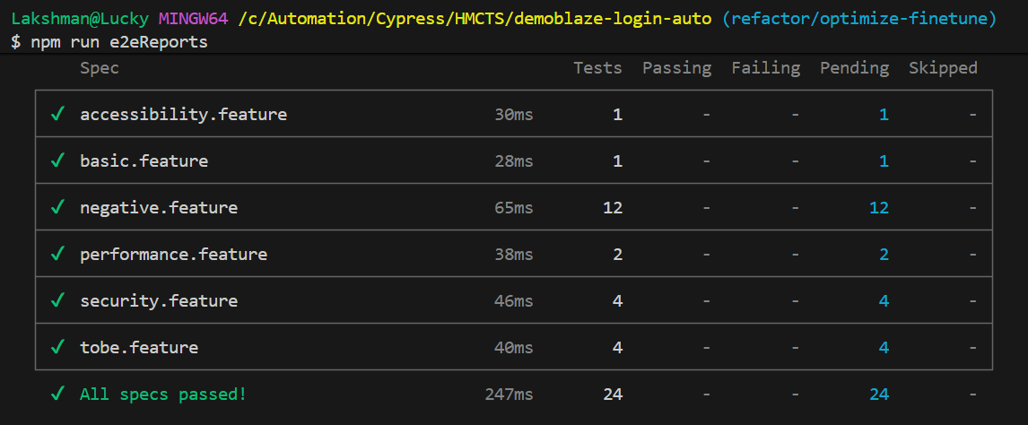

Mochawesom reports are available under :
C:\Automation\Cypress\HMCTS\demoblaze-login-auto\cypress\reports\custom-reports

